Social Networks

Assignment 1

Name: Sara Ayman Abdelbassir
ID: 2205129

1. Introduction

“We analyze and compare a Non-Conspiracy Twitter subgraph vs. a 5G Conspiracy subgraph from the WICO dataset to understand structural differences in information diffusion and community behavior.”

2. Dataset Description
Files Used:
nodes.csv – Contains user IDs and attributes:
id → Unique user identifier
friends → Number of friends/followings
followers → Number of followers

edges.csv – Contains user interactions as edges:
source → User ID of the origin node
target → User ID of the destination node

Network Type:
Directed graph (edges have a direction from source → target)
Each edge represents a follower/friend relationship or interaction between users

Notes:
Converting edges.txt to CSV ensures Gephi can import it without delimiter issues.

3.Network Statistics (from Gephi)
Layout used (Fruchterman Reingold)

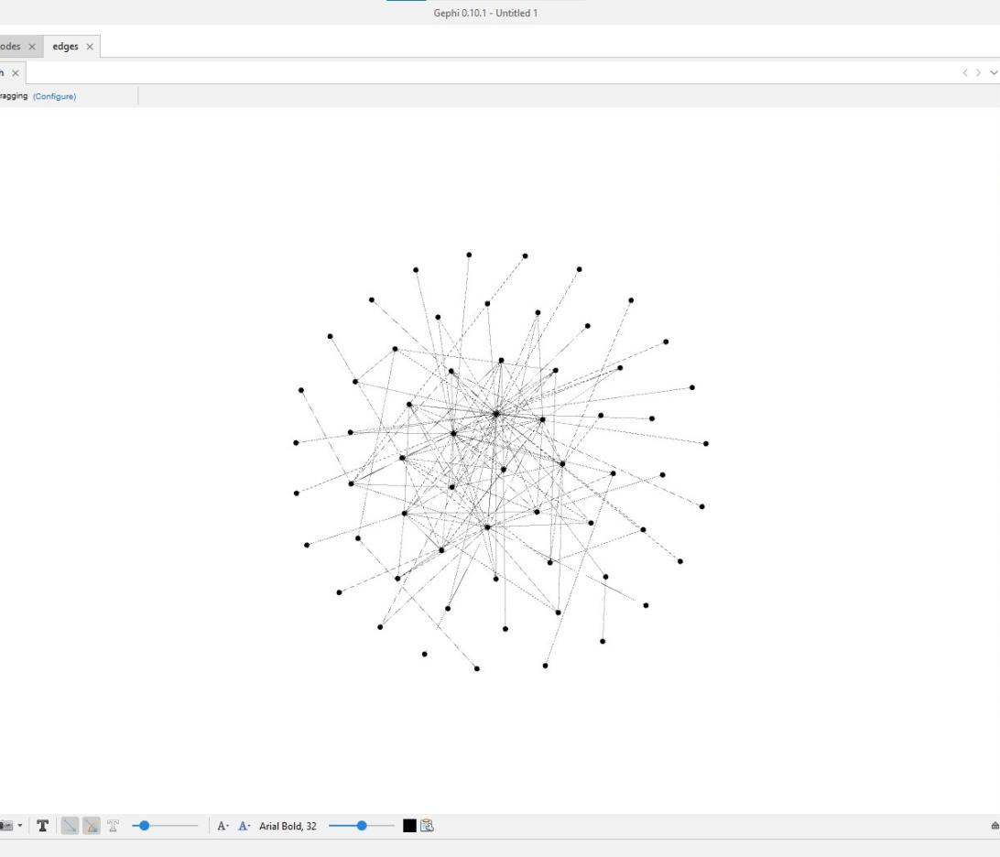

Metrics computed:

Number of nodes and edges:
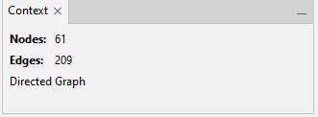

Average degree:

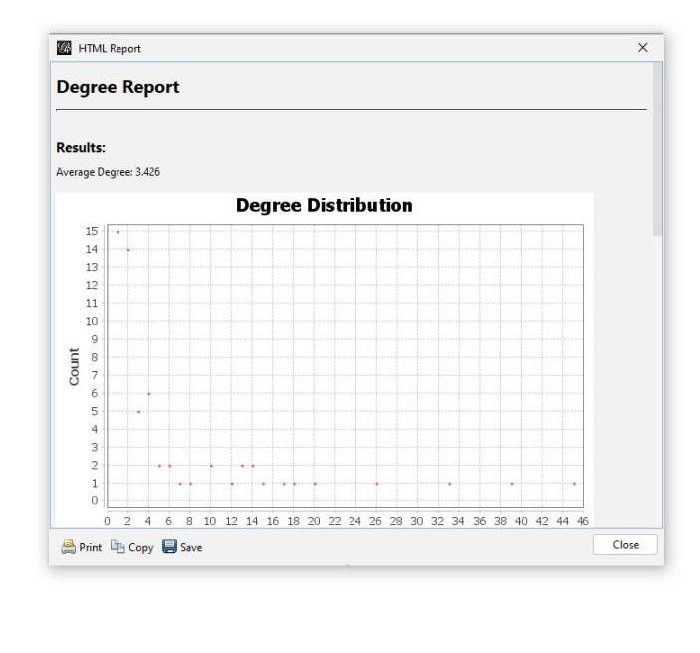

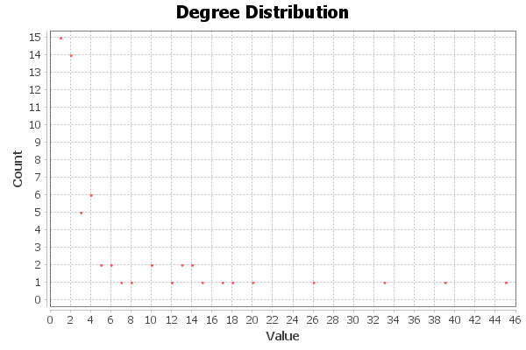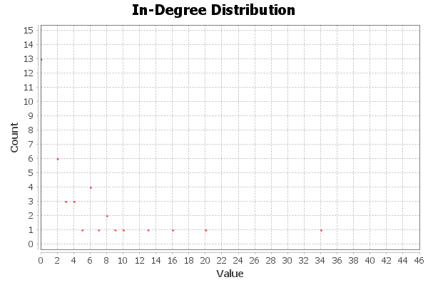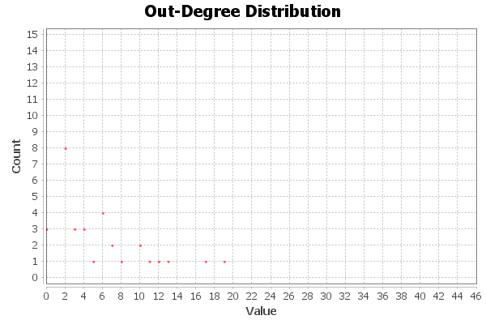

Graph density:

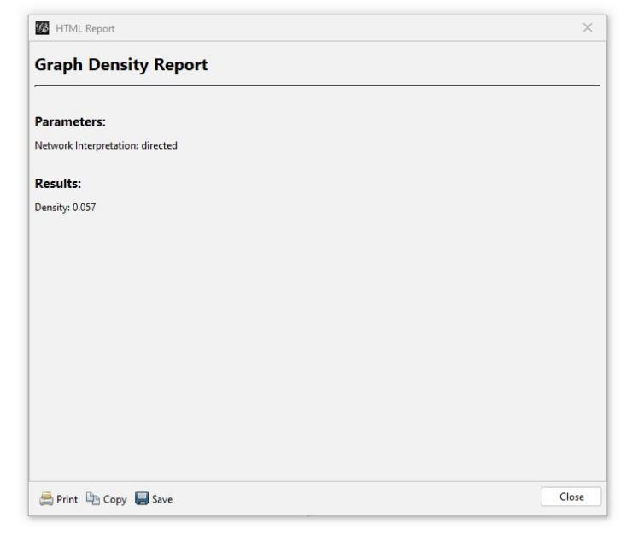

Average clustering coefficient

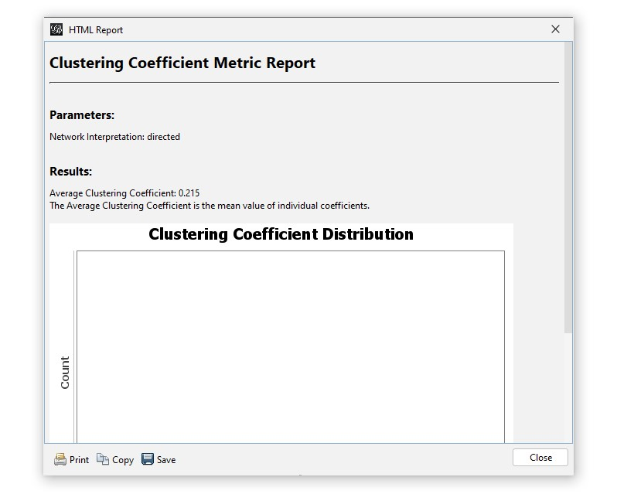

Modularity (Q) and number of communities:

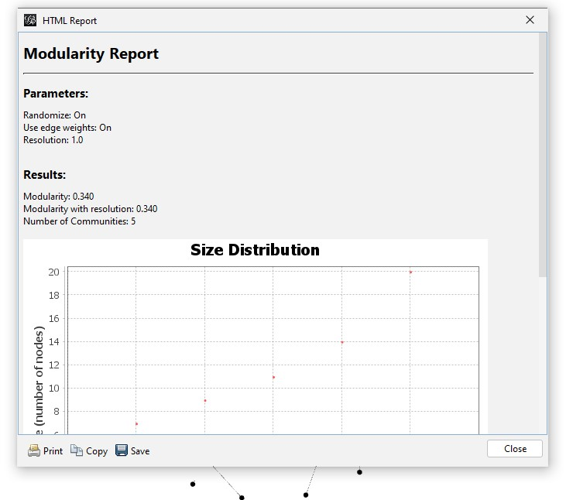

Betweenness and closeness centrality:
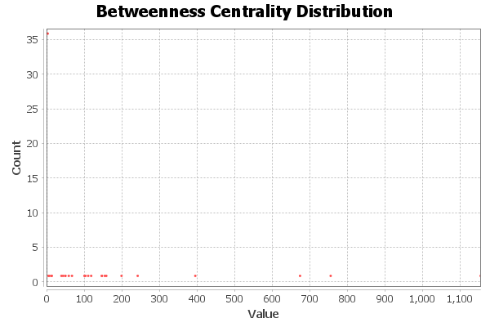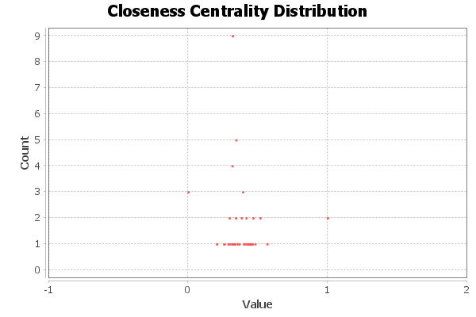

Connected components
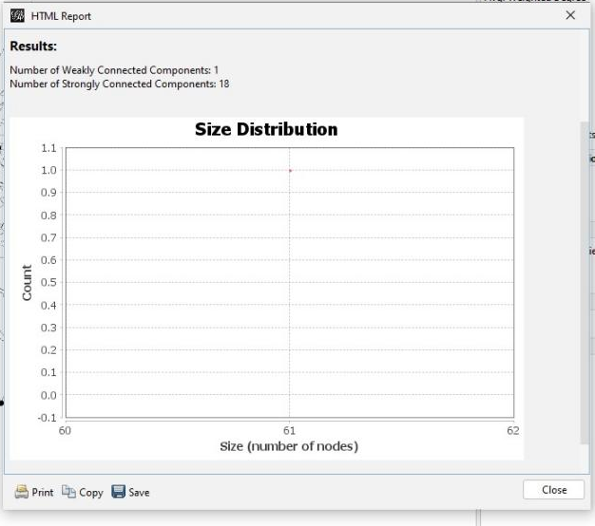

5G Conspiracy Graph
- Introduction
This report analyzes a misinformation network from the WICO 5G_Conspiracy_Graphs dataset.
The goal is to understand the structural patterns of misinformation communities on Twitter and how they differ from normal, non-conspiracy networks.

Using Gephi, we performed:
- Graph visualization (ForceAtlas2 layout)
- Basic network statistics
- Centrality analysis
- Community detection through modularity
- Structural comparisons with a non-conspiracy Twitter graph

2. Dataset Description
Files Used

nodes.csv
- Contains user metadata:
- id — Twitter user ID
- time — Activity timestamp
- friends — Number of accounts the user follows
- followers — Number of followers

edges.csv
- Directed interactions:
- source → User sending the interaction
- target → User receiving the interaction

Network Type
- Directed graph
- Nodes represent Twitter accounts
- Edges represent interactions such as mentions, replies, or retweets

- Visualization
The network was visualized using ForceAtlas2, which showed:

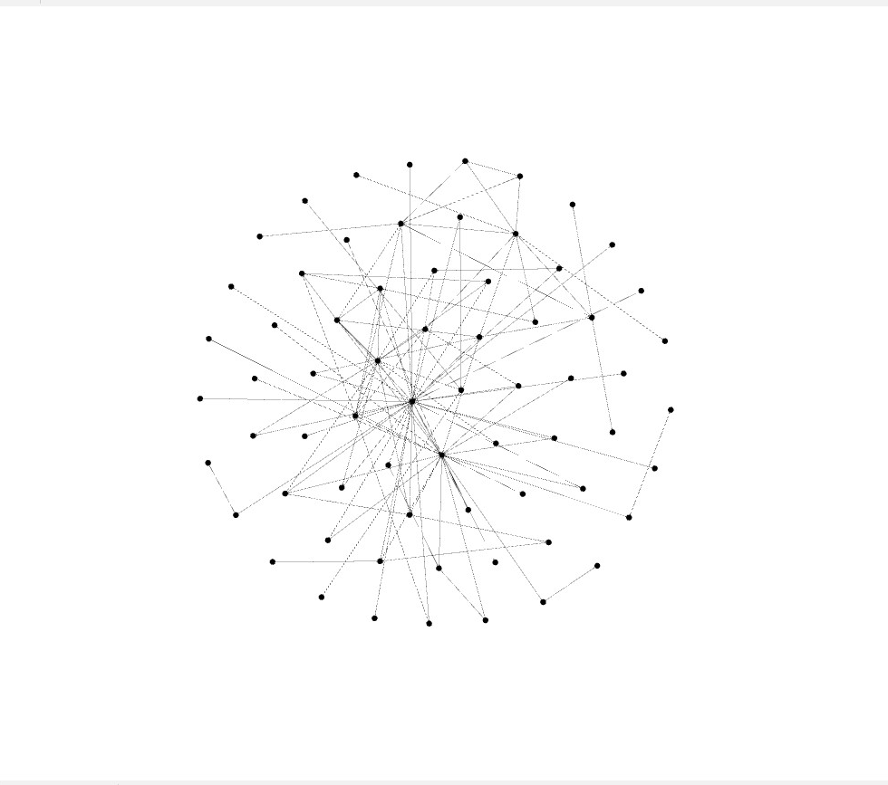

- Network Statistics (from Gephi)

Nodes, Edges
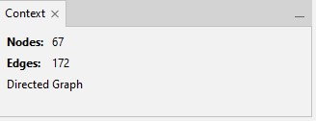

Average Degree

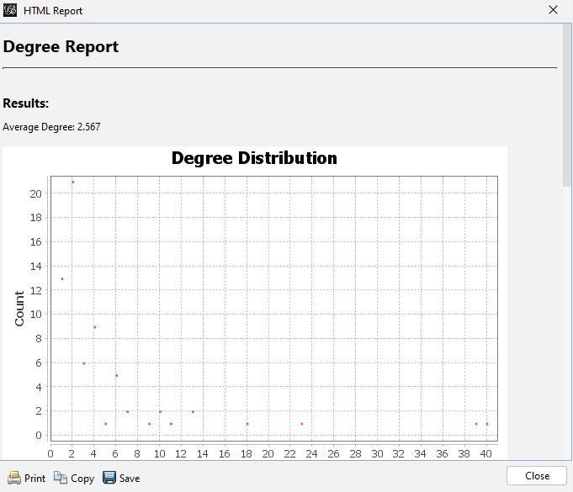

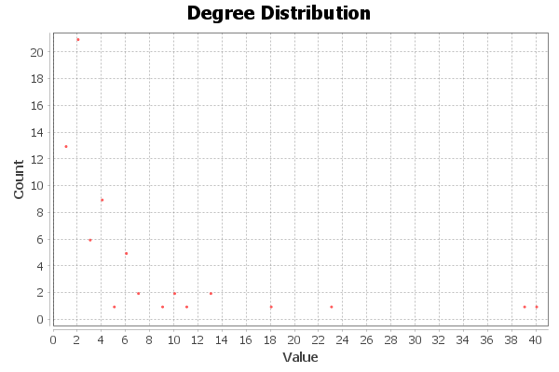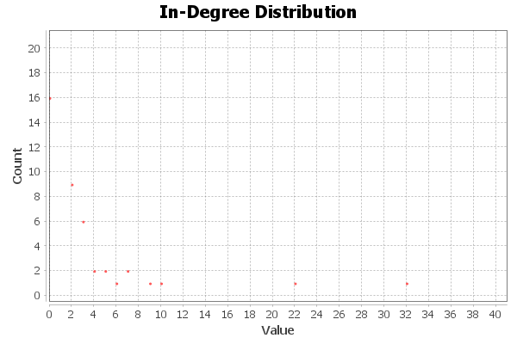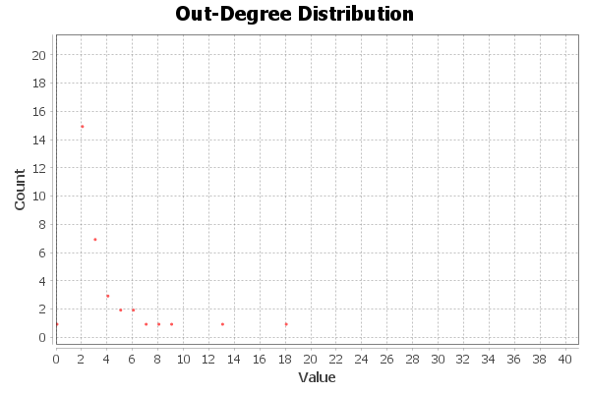

Graph Density
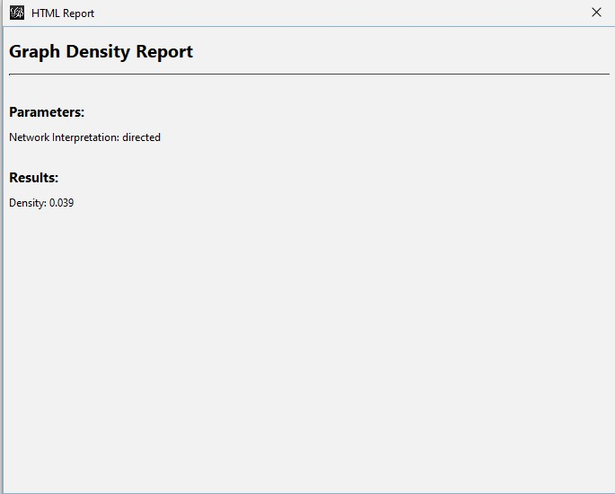

Average Clustering Coefficient
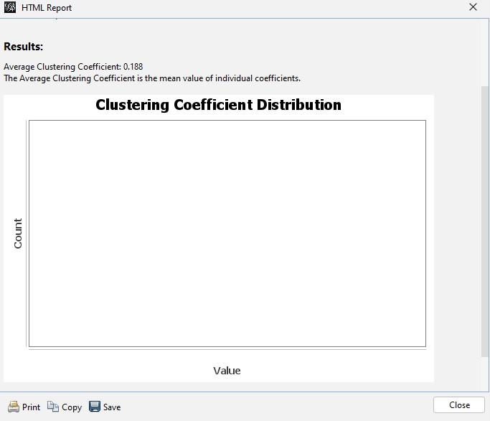

Modularity (Q) and Number of Communities
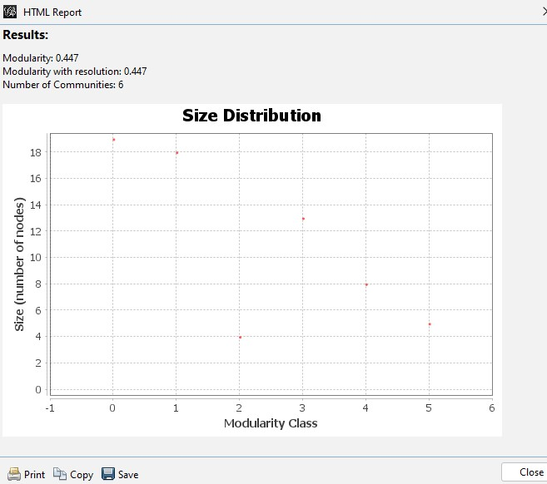

Betweenness & Closeness Centrality

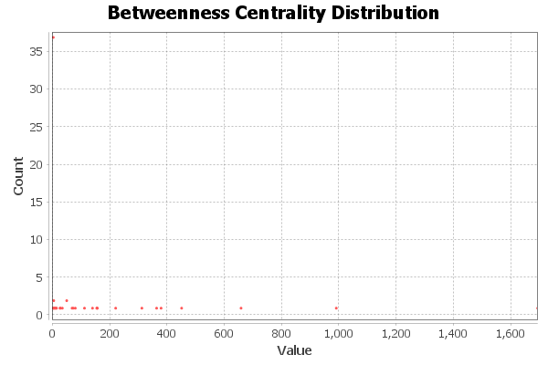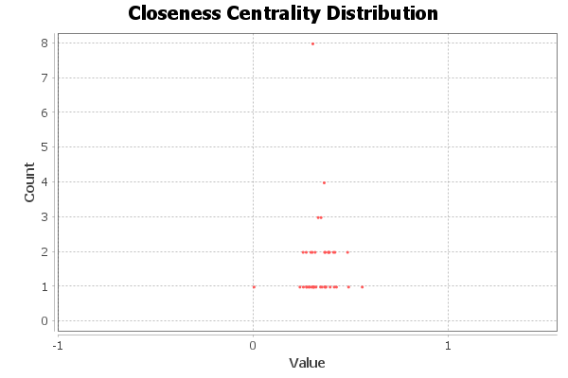

Connected Components
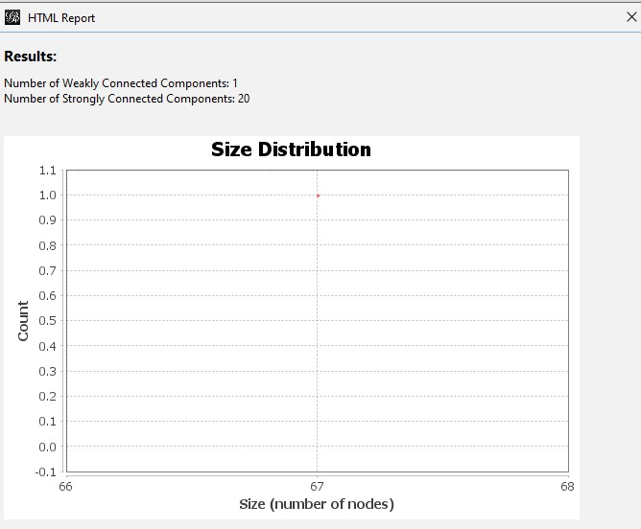

Simple Comparison Between the Non-Conspiracy Network and the 5G Conspiracy Network
1. Number of Users (Nodes) and Connections (Edges)

Non-conspiracy network:
Has more users and more connections.

5G conspiracy network:
Has fewer users and fewer connections.

So: The non-conspiracy network is bigger.

2. Average Degree (How many connections each user has)

Non-conspiracy:
Users have a normal number of connections.

5G conspiracy:
Users often have more connections with each other.

So: Conspiracy users interact more inside their group.

3. Density (How tightly connected the network is)

Non-conspiracy:
Not very dense. People are spread out.

5G conspiracy:
More dense. People interact more often.

So: The conspiracy network is more tightly connected.

4. Clustering (How much users group together)

Non-conspiracy:
Medium clustering.

5G conspiracy:
High clustering. Users stick together and repeat similar ideas.

So: Conspiracy users form stronger groups.

5. Modularity (Number of communities)

Non-conspiracy:
Has many different communities/topics.

5G conspiracy:
Has fewer communities, and they are very similar.

So: Non-conspiracy is diverse; conspiracy is focused on one topic.

6. Central Users (Most influential users)

Non-conspiracy:
Influence is spread between many users.

5G conspiracy:
A few users are very influential and spread the misinformation.

So: Conspiracy networks depend on a few strong “leaders.”

7. Visualization (How the graph looks)

Non-conspiracy:
Looks wide, open, and spread out.

5G conspiracy:
Looks tight and centered, with many users around the same core group.

Final Simple Summary

The non-conspiracy network is bigger, more diverse, and more spread out.
The 5G conspiracy network is smaller, more connected, more clustered, and controlled by a few important users.

